EPA-State 2016 Model Evaluation Forum

Background
- Over the past year there has been a collaborative effort between states, MJOs and EPA to develop a 2016 emissions modeling platform
- A central purpose of this effort was to develop a common emissions platform that could be used by MJOs, states, and EPA as a starting point for various regulatory and policy applications
- The beta version of the 2016 base year emissions has recently been completed
- EPA-OAQPS has prepared 2016 data for other model inputs (WRF meteorology, ICBCs, etc.) and has completed annual 2016 CAMxv6.5 and CMAQv5.2.1 model simulations using the beta emissions for 36 km and 12 km modeling domains (see appendix for map)
- A central piece of the platform development effort is the evaluation of 2016 base year air quality model predictions using measured data
  - The results of the model evaluation are important for understanding the strengths and weaknesses of the platform which, in turn, help inform the use of the platform and guide research efforts to improve model inputs and science.
- In response to feedback from some EPA ROs, MJOs, and states, we’re proposing to engage more broadly with these organizations through a collaborative forum to evaluate the 2016 platform air quality modeling

Purpose and Structure of 2016 Platform Evaluation Forum
- The forum will
  - promote collaboration with state partners on characterizing and understanding model performance and identifying performance issues for possible further research by EPA and/or the modeling community.
  - serve as a venue for sharing data and evaluation results – OAQPS plans to share both model output and preliminary evaluation plots/stats from the 2016 beta simulation
  - serve as a resource for modelers who intend to use the 2016 modeling platform
  - serve as a venue to consider forming working teams that will independently meet and investigate model performance issues of mutual interest
- Forum members will mainly consist of technical staff from EPA, ROs, MJOs, and states
- The forum is not intended to serve as a decision-making body on the utility and applicability of the platform for any particular air quality assessment
- The forum may continue beyond completion of reports to facilitate/coordinate longer-term efforts to improve model performance, where needed

Guiding Principles for Model Evaluation
  - “Models are models”. That is, modeling systems will never provide, and should not be expected to provide, a perfect match to measured data for all hours of all days under all emissions and meteorological conditions.
  - Models are best viewed in terms of their capability to provide a distribution of predicted concentrations representative of corresponding measured concentrations under conditions (i.e., concentration levels, meteorology, emissions) relevant to regulatory actions (e.g., conditions typically associated with measured nonattainment in the area of interest)
  - Modeling results should not be judged exclusively or primarily using singular, bright line numerical criteria.
  - For current “state-of-the science” photochemical modeling systems, the uncertainty associated with base year performance for many pollutants is likely to be dwarfed by the uncertainty associated with the inability to precisely know future year conditions (e.g., meteorology and emissions) that will determine the actual future year concentrations.
  - The regulatory and academic community should continue to test and evaluate models in order to understand model performance and model responsiveness in part to guide and encourage “policy-relevant” science improvements to these models with the goal of improving model performance over time

Operational Model Evaluation
- Scope of initial operational evaluation to be prepared by OAQPS
  - Species to be included:
    - Ozone: MDA8, MDA8 on days > 60 ppb, hourly
    - NOy species: NO, NO₂, NO_{x}, NO_{y}
    - NH₃
    - PM species: OC, EC, sulfate, nitrate, ammonium, SOIL, total PM_{2.5}
    - VOC species: benzene, formaldehyde, acetaldehyde, isoprene
    - Wet deposition: sulfate, nitrate, ammonium
  - Evaluation will occur for both CMAQ and CAMx focusing on results from the 12US2 domain
    - Boundary condition and meteorological input performance are being evaluated separately.
  - Plots/tables for all species (see Appendix for examples)
    - Dot maps by season: MB, NMB, ME, NME
    - Monthly boxplots by region
    - Diurnal boxplots by season/region
    - Density scatter plots by season/region
    - Individual site and multi-site timeseries
    - Spatial plots with ambient data overlay by region for key species, including ozone and PM2.5 species from IMPROVE network.
    - Spatial difference plots of CAMx and CMAQ by region for key species.
    - Tabulated statistics by season/region/network
      - Stats calculated: avg obs, avg mod, n, MB, NMB, ME, NME, FB, FE, r
  - Compare 2016 model statistics to past performance results from previous annual model runs
- Potential expanded evaluation via working teams established as part of the forum
  - Examine, understand, and interpret pollutant and/or geographic-specific model performance issues and make recommendations for sensitivity analyses and further research to address these issues
  - Comparison of model vertical ozone profiles to ozonesonde and TOLNet ozone lidar data.
  - Evaluation of 4km modeling result for domains covering the Northeast, the Midwest, and California

Data Exchange with Forum Participants
- EPA’s 2016 beta CMAQ/CAMx data will be made available to forum participants
  - Hourly and Daily Layer 1 IOAPI model output files: TBD
  - Site-compare csv files (paired model-obs data) for all listed species: TBD
  - OAQPS operational evaluation plots/tables will be shared through LADCO system
  - OAQPS will explore development of a map-based tool for querying data and creating plots for specific locations/times of interest
- Sharing of data created by MJOs/states: TBD

Next Steps
- Follow-up to this March 15 call
  - MJOs reach out to states with forum charter
  - MJOs and states provide feedback on forum charter
  - MJOs and states identify interested staff members and contact Heather
- Initial Forum call will present available data (what is available, how to access) and OAQPS key take-aways from preliminary operation evaluation
  - Homework: browse available data, come up with evaluation interests
- Follow-up Forum call with general discussion leading to:
  - Prioritized list of model evaluation topics for further investigation
  - Working teams who will set-up independent meetings and analysis calls
- Periodic Forum calls for work-group updates
- Webinar or workshop to present work-group preliminary results in 9-12 months
- 2016 platform evaluation work will wrap up by end of 2019. Forum meetings and investigation of model performance issues that require longer term evaluations and development may continue depending on needs/interest of participants

Model domains:
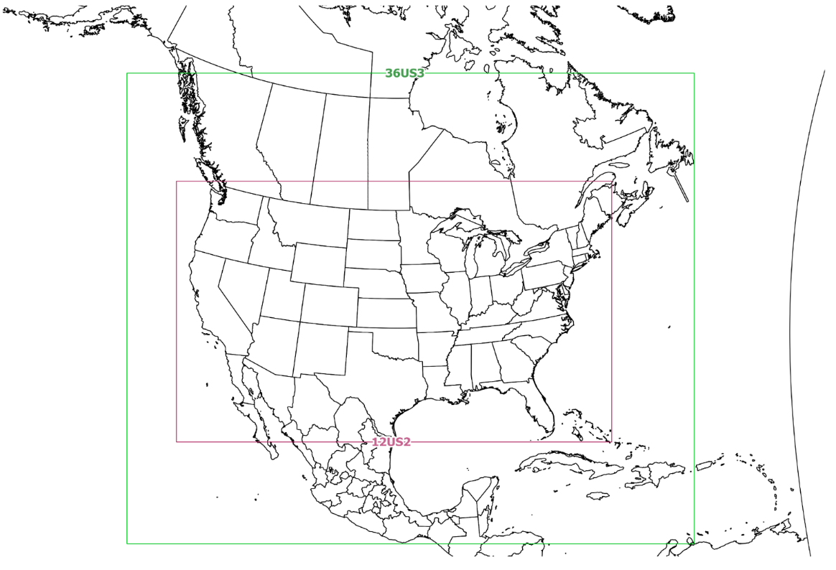

Statistics and plots reported using NOAA climate regions:
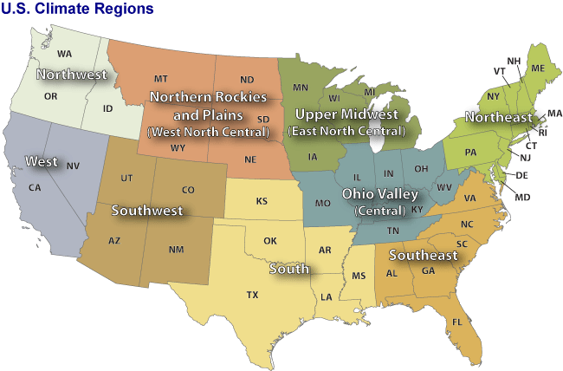

Appendix: Example Plots Based on 2016 “v0” Emissions

Dot map by season example: 2016v0 CAMx MDA8 O₃ Jun/Jul/Aug NMB (%)
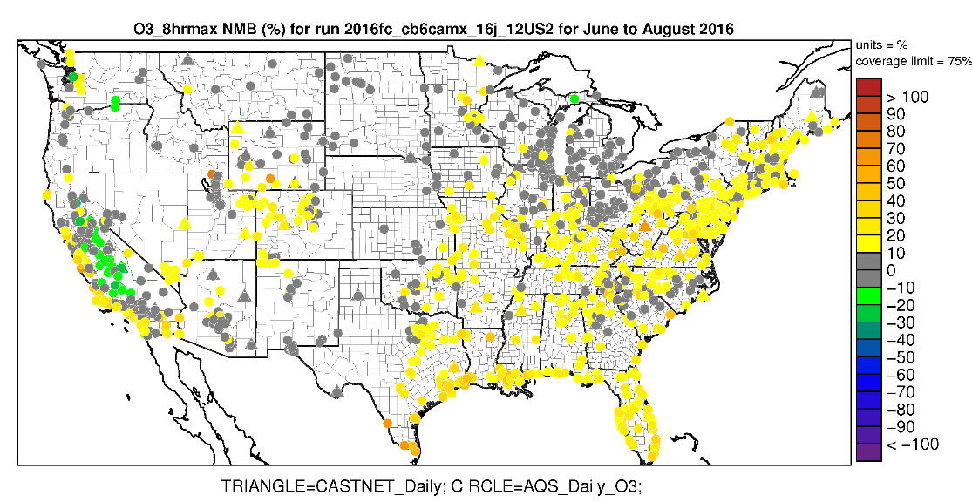
Monthly boxplot by region example: 2016vo CMAQ and CAMx PM_{2.5} Nitrate at CSN sites in the Ohio Valley

Diurnal boxplot by season/region example: 2016v0 CMAQ and CAMx May-Sep NO₂ in the Northeast region
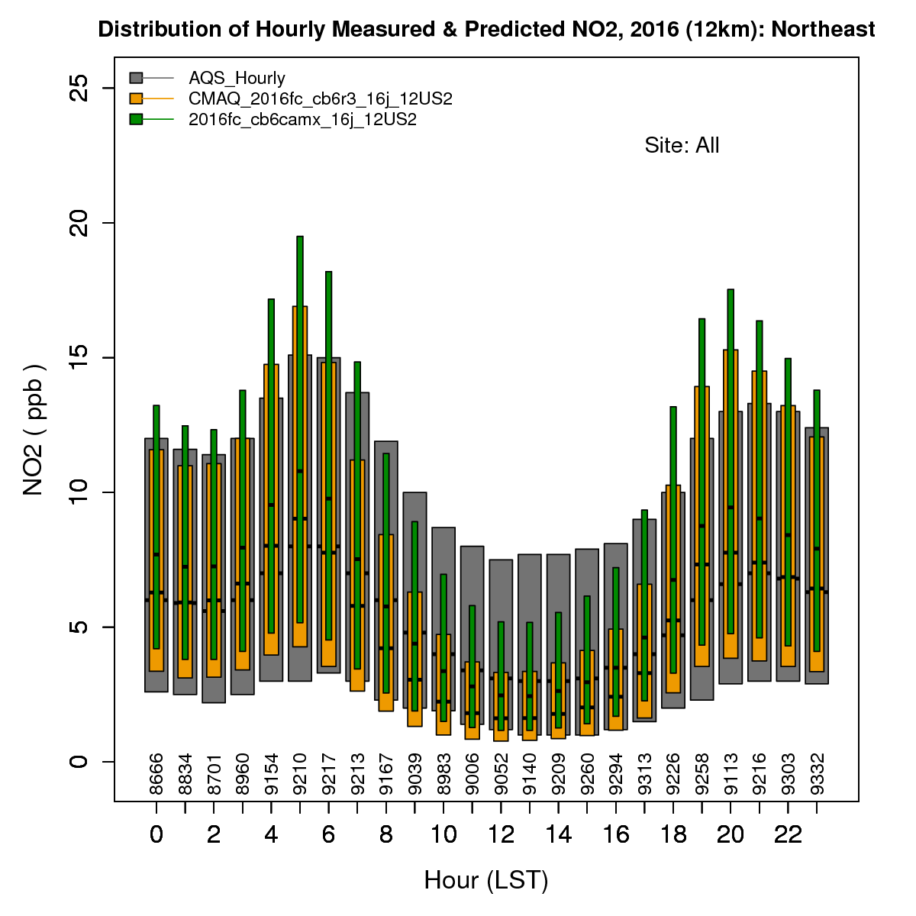
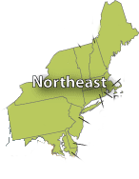

Density scatter plot by season/region example: 2016v0 CAMx Mar/Apr/May MDA8 O₃ in the upper midwest
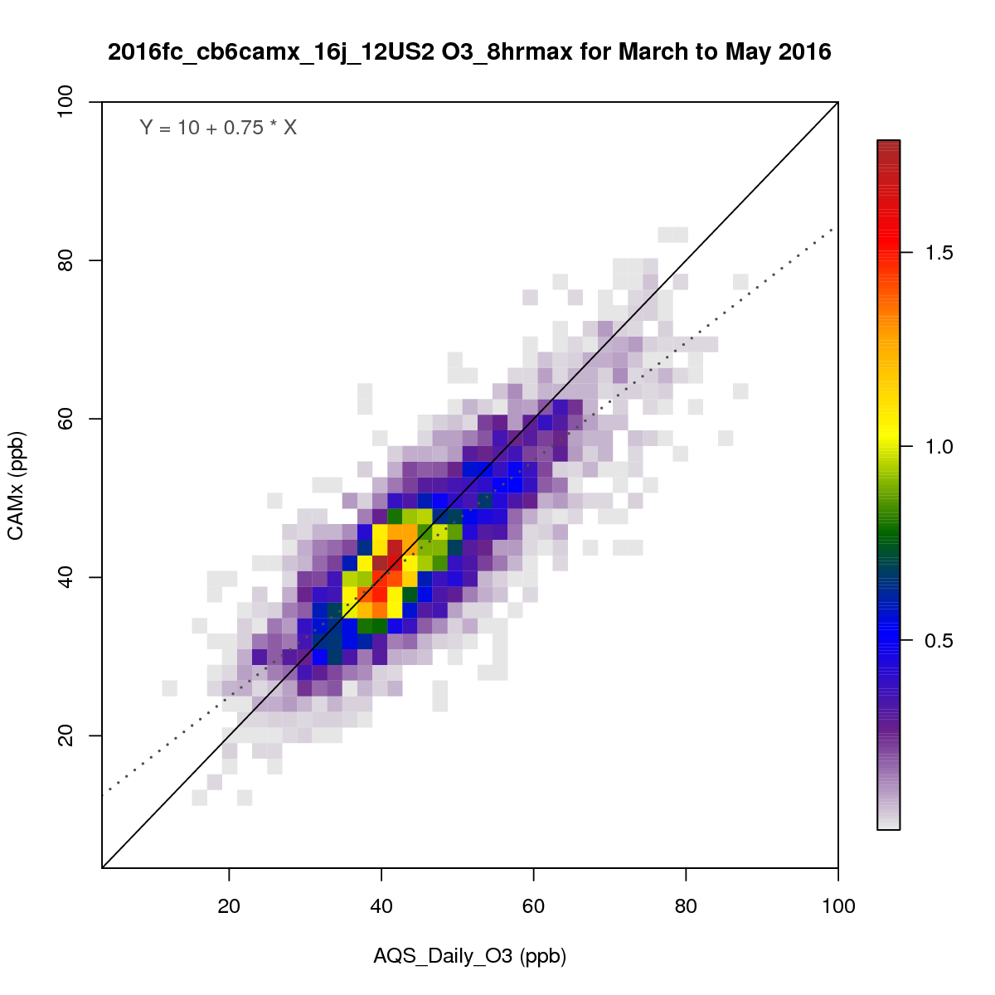
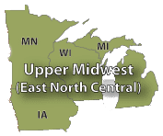

Multi-site timeseries example: 2016v0 CMAQ and CAMx Jun/Jul/Aug PM_{2.5} sulfate in the South region
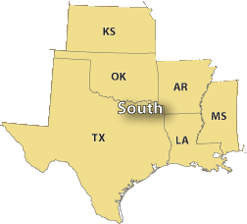

Spatial model-obs overlay plot example:2016beta CMAQ MDA8 Ozone on July 22 in the Northeast US

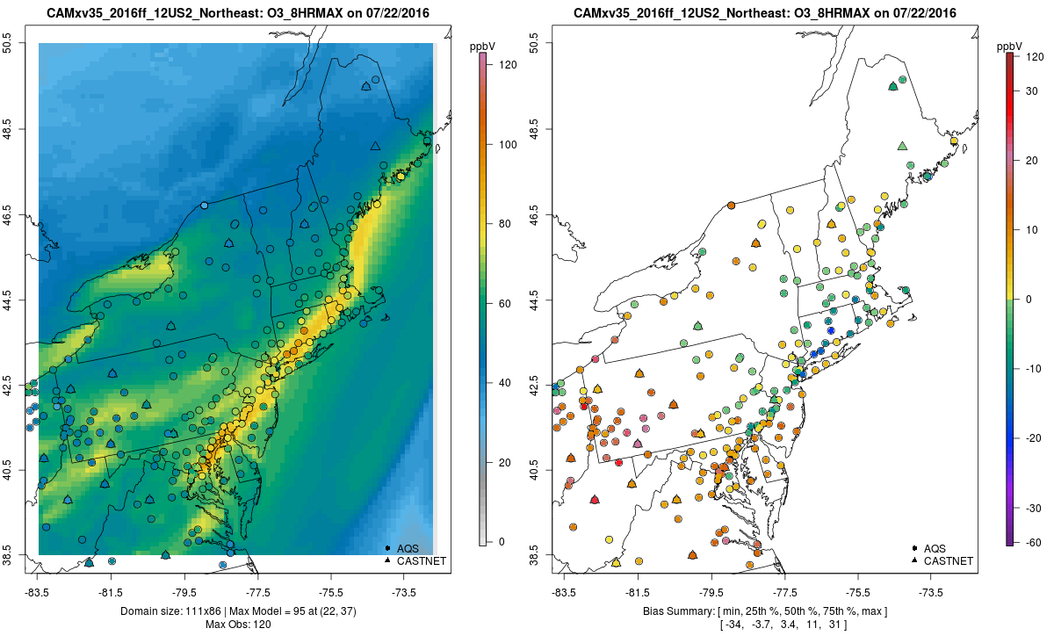

CMAQ vs CAMx model difference plot example:2016beta monthly mean MDA8 Ozone for July
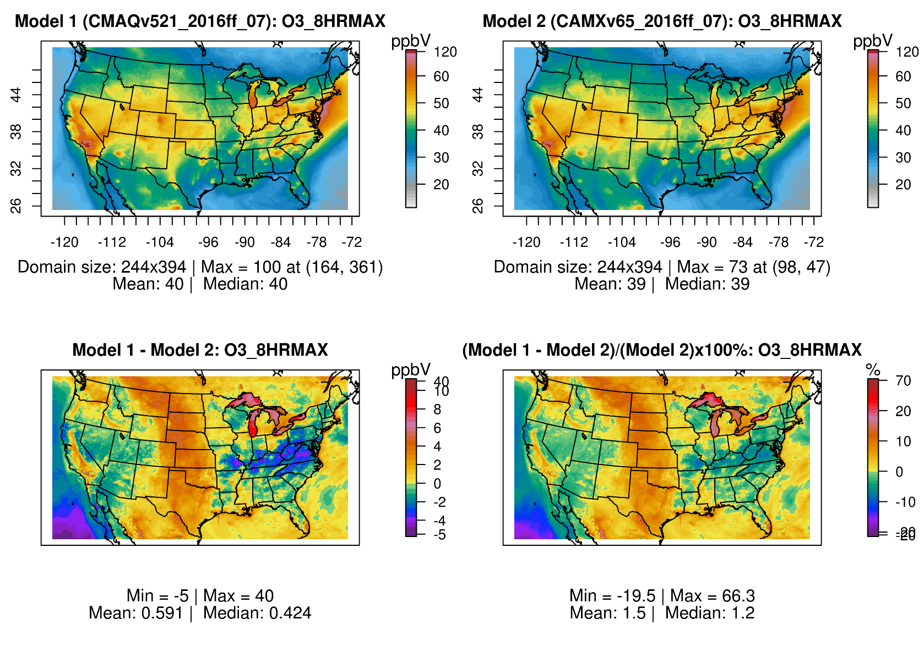

Preliminary evaluation of hemispheric model simulation that was used to create boundary conditions can be found in the Henderson et al presentation entitled “Hemispheric-CMAQ Application and Evaluation for 2016” available on the 2018 CMAS conference website: https://www.cmascenter.org/conference/2018/agenda.cfm. Preliminary evaluation of the 2016 WRF outputs will be linked from the wiki for the 2016 beta emissions at: http://views.cira.colostate.edu/wiki/wiki/9169.

